# Air optix Aqua

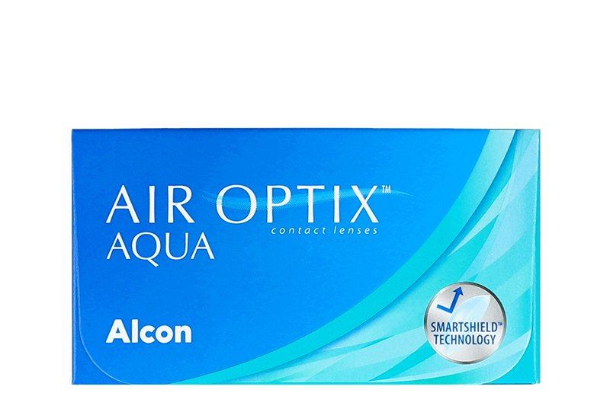

Product information

|  |  |
| --- | --- |
| **Brands** | Air Optix |
| **Availability** | While supplies last. This product is being discontinued by the manufacturer. |
| **Replacement** | Monthly |
| **Material** | 67% lotrafilcon B polymer, 33% H2O |

Description

**Air Optix Aqua contact lenses are manufactured by Alcon. Air Optix Aqua lenses feature the Aqua Moisture System; a patented moisture agent that helps lubricate and maintain moisture on the lens. 1 month replacement is recommended.  
  
*Limited time offer. While supplies last. Only on your Air Optix Aqua order on this website. Discount applied on the current website price at the time of order. Cannot be combined with any other offers. Promotions are subject to change without notice. We reserve the right to cancel orders that are in breach of the terms and conditions of this offer.**